Zoe Boyle

Lab 7

Question 1



getPhoneNumber.c

#include <stdio.h>

int x, y, z = 0;

int main()

{

printf("Enter phone number [(999) 999-9999]:");

scanf("(%d) %d-%d", &x, &y, &z);

printf("You Entered: %d-%d-%d", x, y, z);

return 0;

}

Question 2

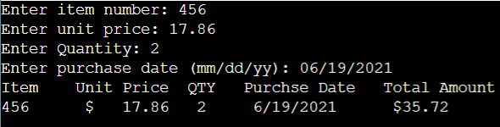

calcPrice.c

#include <stdio.h>

int item, quant, m, d, y = 0;

float price = 0;

int main()

{

printf("Enter item number: ");

scanf("%d", &item);

printf("Enter unit price: ");

scanf("%f", &price);

printf("Enter Quantity: ");

scanf("%d", &quant);

printf("Enter purchase date (mm/dd/yy): ");

scanf("%d/%d/%d", &m, &d, &y);

printf("Item Unit Price QTY Purchse Date Total Amount\n");

printf("%d $ %.2f %d %d/%d/%d $%.2f", item, price, quant, m, d, y, price\*quant);

return 0;

}